Final PROJECT

CS634105 DATA MINING

Subject: Final Project Implementation

Topic: Random forest, KNN & LSTM

Name: Zal Patel

Email: zp63@njit.edu

**Dataset Description**

**Title:**

Credit Card Fraud Detection Dataset

URL:

<https://www.kaggle.com/mlg-ulb/creditcardfraud>

**Discription:**

This dataset contains large amount of values which consists of details like from v1, v2, v3,….till v28 and Amount and Class.

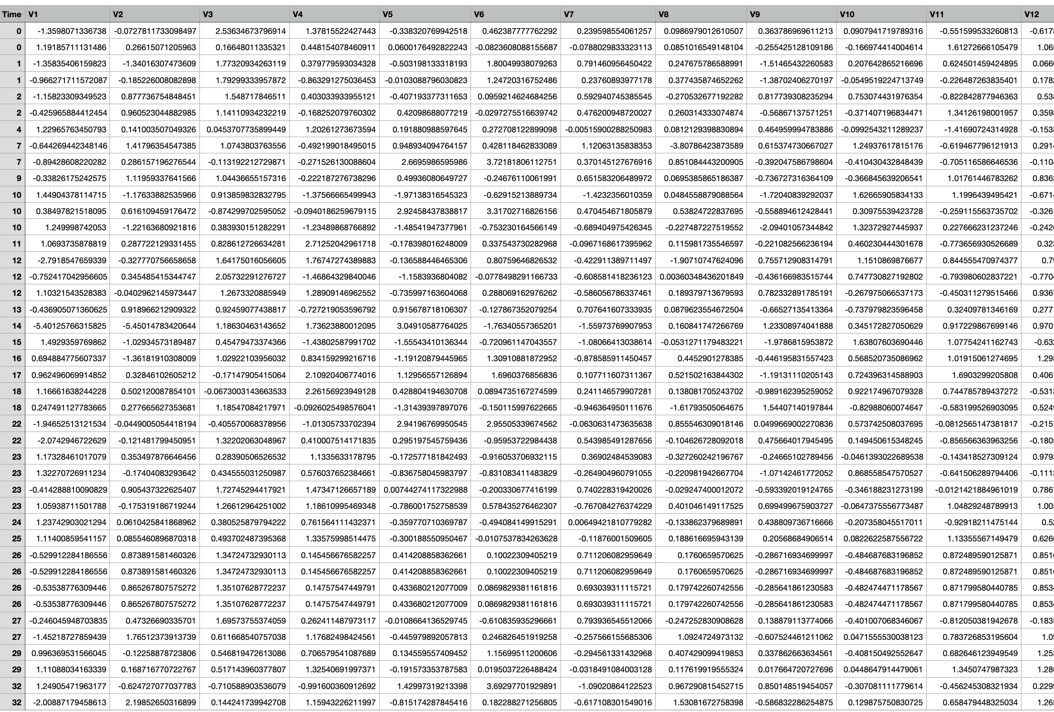

**Data in CSV file**

Random Forests:

* Random forest is a supervised learning algorithm.
* The "forest" it builds, is an ensemble of decision trees, usually trained with the “bagging” method.
* The general idea of the bagging method is that a combination of learning models increases the overall result.
* One big advantage of random forest is that it can be used for both classification and regression problems, which form most current machine learning systems.
* Random forest in classification since classification is sometimes considered the building block of machine learning.

K-Nearest Neighbor (KNN):

* It is a classifier and learns from the training datasets.
* K nearest neighbors determined by calculating Euclidean distance.
* Select neighbors with minimum distance from unlabeled test object.
* Unlabeled neighbors are classified according to the rule of majority.

LSTM (Long Short-Term Memory):

* LSTM is an **a**ppropriate gradient-based learning algorithm.
* Long Short-Term Memory (LSTM) networks are recurrent neural networks that can learn order dependency in sequence prediction challenges.
* This is a necessary behavior in complicated problem areas like as machine translation, speech recognition, and others.

**Accuracy, Cross-Validation and K-Fold**

Accuracy:

* Accuracy is defined as the percentage of correct predictions for the test data.
* It can be calculated easily by dividing the number of correct predictions by the number of total predictions.
* 𝐴𝑐𝑐𝑢𝑟𝑎𝑐𝑦 = 𝐶𝑜𝑟𝑟𝑒𝑐𝑡 𝑃𝑟𝑒𝑑𝑖𝑐𝑡𝑖𝑜𝑛 𝐴𝑙𝑙 𝑝𝑟𝑒𝑑𝑖𝑐𝑡𝑖𝑜𝑛 / 𝐴𝑙𝑙 𝑝𝑟𝑒𝑑𝑖𝑐𝑡𝑖𝑜𝑛

Cross-validation:

* Cross-validation is an important concept in machine learning which helps the data scientists in two major ways:
* It can reduce the size of data.
* It ensures that the model is robust enough.
* Cross validation does that at the cost of resource consumption.

K-Fold:

* K-Folds cross-validator.
* Provides train/test indices to split data in train/test sets. Split dataset into k consecutive folds (without shuffling by default).
* K-Fold divides all the samples in groups of samples, called folds (if k = n, this is equivalent to the Leave One Out strategy), of equal sizes (if possible).
* The prediction function is learned using k-1 folds, and the fold left out is used for test.

Accuracy Comparison:

On comparing the accuracies of both the classifiers and LSTM, we could say that the accuracy of Random Forest and KNN is more than of LSTM of accuracy.

The accuracies are as follow:

Random Forest Classifier is 99.95

KNN Classifier is 99.95

LSTM is 99.82

Source Code

